Profile of the

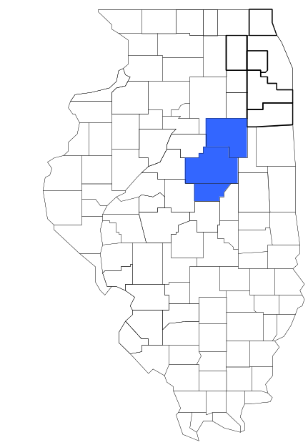Task Force 6

Prepared by

The Research and Analysis Unit of the
Illinois Criminal Justice Information Authority

George H. Ryan, Governor
Peter B. Bensinger, Chairman
Candice M. Livingston, Executive Director

March 2001



ILLINOIS
CRIMINAL JUSTICE
INFORMATION AUTHORITY

This project was supported by Grant # 99-DB-BX-0017, awarded to the Illinois Criminal Justice Information Authority by the Bureau of Justice Assistance, Office of Justice Programs, U.S. Department of Justice. The Assistant Attorney General, Office of Justice Programs, coordinates the activities of the following programs, offices and bureaus: Bureau of Justice Assistance, Bureau of Justice Statistics, National Institute of Justice, Office of Juvenile Justice and Delinquency Prevention, and the Office for Victims of Crime. Points of view or opinions contained within this document are those of the authors and do not necessarily represent the official position or policies of the U.S. Department of Justice.

Illinois Criminal Justice Information Authority
120 S. Riverside Plaza, Suite 1016
Chicago, Illinois 60606-3997
Telephone (312) 793-8550
Telefax (312) 793-8422
TDD: (312) 793-4170
World Wide Website http://www.icjia.state.il.us
ACKNOWLEDGMENTS

A number of organizations and individuals put a great deal of effort into the development of this document. The Authority’s Research and Analysis Unit is very grateful for the assistance provided by the following organizations:

Administrative Office of the Illinois Courts
Illinois Department of Human Services’ Office of Alcoholism and Substance Abuse
Illinois Department of Children and Family Services
Illinois Department of Corrections
Illinois State Police
Task Force 6
U.S. Bureau of the Census

In addition, the following individuals were instrumental in gathering, interpreting and presenting these data:

Sharyn Adams

Megan Alderden

Robert Bauer

Alissa Clark

John Condne

Karen Griffiths

Tracy Hahn

Jennifer Hiselman

David Katz

Joseph Kozenczak

Gary Kupsak

Erica Morrow

David Olson

Adrianna Perez

Gerard Ramker

Robert Taylor

CONTENTS

Section Page Number

EXECUTIVE SUMMARY

I. Introduction 1
II. Trends in Violent Index Offenses and Arrests 3
III. Trends in Drug Arrests 6
IV. Trends in Drug Seizures 14
V. Trends in Prosecutions for Drug Offenses 16
VI. Trends in Percent of Convicted Drug Offenders Sentenced to Prison 18
VII. Trends in Drug Treatment Admissions in Task Force 6 Region by Drug Type 23
VIII. Trends in Drug Exposed Births 26
IX. Summary of Drug Situation 27
X. Appendices 29
Map 1 1999 Percent of Illinois' County-level Population Covered by an
Authority-funded Multi-jurisdictional Enforcement Group or Task Force 30
Map 2 1999 Illinois Cannabis Seizure Rates, by County 31
Map 3 1999 Illinois Controlled Substances Seizure Rates, by County 32
Map 4 1999 Illinois Methamphetamine Seizure Rates, by County 33
XI. Bibliography 34

LIST OF FIGURES

Figure Page Number

Figure 1. Violent Index Offense Rates for Participating and Non-participating Agencies in Region Covered by Task Force 6 3
Figure 2. 1999 Violent Index Offenses* Reported by Participating and Non-participating Agencies in Region Covered by Task Force 6 4
Figure 3. Violent Index Arrest Rates for Participating and Non-participating Agencies in Region Covered by Task Force 6 5
Figure 4. 1999 Violent Index Arrests* Reported by Participating and Non-participating Agencies in Region Covered by Task Force 6 5
Figure 5. Total Drug Arrest Rates for Task Force 6 and Participating and Non-participating Agencies in Region Covered by Task Force 6 7
Figure 6. 1999 Drug Arrests* Reported by Participating and Non-participating Agencies in Region Covered by Task Force 6 7
Figure 7. Total 1999 Drug Arrests* Reported by Participating and Non-participating Agencies in Region Covered by Task Force 6, by Drug Type 8
Figure 8. Drug Arrests by Task Force 6 9
Figure 9. Percent of Total Drug Arrests Accounted for by Task Force 6 9
Figure 10. Cannabis Arrests Rates in the Region Covered by Task Force 6 as Reported by Participating Agencies, Non-participating Agencies and Task Force 6 10
Figure 11. Percent of Cannabis Arrests Accounted for by Task Force 6
11
Figure 12. Controlled Substances Arrest Rates in the Region Covered by Task Force 6 as Reported by Participating Agencies, Non-participating Agencies and Task Force 6 12
Figure 13. Percent of Controlled Substances Arrests Accounted for by Task Force 6 12
Figure 14. Task Force 6 Drug Arrests for Possession versus Delivery, by Drug Type 13
Figure 15. Cannabis Seized and Submitted to ISP by DeWitt, Livingston and McLean Counties and Seized by Task Force 6 14
Figure 16. Powder and Crack Cocaine Seized and Submitted to ISP by DeWitt, Livingston and McLean Counties and Seized by Task Force 6 15
Figure 17. Number of Felony Filings in DeWitt, Livingston and McLean Counties 16
Figure 18. Total Task Force 6 Drug Arrests and Percentage of Arrests Resulting in Prosecution 17
Figure 19. Sentences Imposed on Felons Convicted in DeWitt, Livingston and McLean Counties
18
Figure 20. Sentences Imposed on Convicted Task Force 6 Drug Offenders 19
Figure 21. Number of Drug Offenders Committed to IDOC by Task Force 6 and Region Covered by Task Force 6 20
Figure 22. Drug Offenders as a Percent of Total IDOC Commitments from DeWitt, Livingston and McLean Counties 21
Figure 23. Drug Offenders Committed to IDOC from DeWitt, Livingston and McLean Counties, by Offense Class 22
Figure 24. Substance Abuse Treatment Admissions from DeWitt, Livingston and McLean Counties 23
Figure 25. Comparison of Drug Arrests by Task Force 6 and Participating and Non-participating Agencies vs. Drug Abuse Treatment Admissions in DeWitt, Livingston and McLean Counties, SFY 99 25
Figure 26. Cases of Drug-Exposed Infants in DeWitt, Livingston and McLean Counties 26
Figure 27. Availability of Drugs in Illinois, 1998 27
Figure 28. Price Per Gram in Illinois, 1998 28

EXECUTIVE SUMMARY

Since 1989, the Authority’s Research and Analysis Unit has received funds under the federal Anti-Drug Abuse Act of 1988 to document the extent and nature of drug and violent crime in Illinois and the criminal justice system’s response to these offenses. As a result of these efforts, the Authority has amassed a large amount of data measuring the extent and nature of drug and violent crime in Illinois and the impact these crimes have had on the criminal justice system. In addition, as part of its monitoring and evaluation efforts, the Authority also requires funded programs to submit monthly data reports describing their activities and accomplishments. This profile is intended to provide a general overview of the drug and violent crime problem in the jurisdictions covered by Illinois’ MEGs and task forces, and the response to these problems by the units.

Although the data presented in this report are by no means inclusive of all indicators, they do provide a general overview of drug and violent crime and the response and impact of the criminal justice system. The following represent general conclusions that can be made based on the data analyzed for this report.

- In 1999, eight local Illinois police agencies participated in Task Force 6 (a participating agency is defined as one that contributes either personnel or financial resources to Task Force 6). Officers assigned to Task Force 6 (totaling 16 in 1999, eight from participating agencies) accounted for less than 3 percent of the total number of sworn police officers working for agencies participating in Task Force 6.

- The violent Index offense rate was collectively higher across jurisdictions that participated in Task Force 6 than among the combined jurisdictions that did not participate in Task Force 6 (page 3).

- The drug arrest rate was higher collectively in those jurisdictions that participated in Task Force 6 than in those jurisdictions not participating in Task Force 6. The drug arrest rate achieved by Task Force 6 was much smaller than that achieved by either participating or non-participating agencies (page 6).

- When comparing the types of drug offenders arrested by those agencies participating in Task Force 6, those agencies not participating, and Task Force 6, it was found that Task Force 6 tended to target and arrest more serious drug law violators in 1999, specifically violators of the Controlled Substances Act, which tend to be felony-level offenses (page 8).

- The majority of all drug arrests reported by Task Force 6, for either violations of the Cannabis Control Act or the Controlled Substances Act, involve drug sale or delivery (page 13).

- Between 1993 and 1999, the amount of cannabis and cocaine seized by Task Force 6 increased (pages 14 and 15).

- Between 1991 and 1999, 85 percent of all drug arrests by Task Force 6 resulted in prosecution. Of these Task Force 6 drug offender prosecutions, 58 percent were for violations of Controlled Substances Act. In addition, between 1989 and 1999, 67 percent of all drug offenders who were prosecuted as a result of Task Force 6 activity were convicted (page 17).

- In 1999, among those Task Force 6 drug offenders convicted and sentenced, prison sentences accounted for the largest proportion (55 percent), followed by jail sentences (33 percent) and probation sentences (12 percent) (page 19).

- Between 1989 and 1999, prison sentences resulting from Task Force 6 cases accounted for 27 percent of all drug-law violators sent to prison from the region where Task Force 6 operates (page 20).

- Unlike the arrests made by the participating and non-participating agencies, the arrests made by Task Force 6 tended to involve the substances considered to be most serious (i.e., felony versus misdemeanor) and the substances for which a good proportion of community residents were seeking and receiving substance abuse treatment in 1999 (page 24).

I. Introduction

The Task Force 6 (Task Force 6) covers the Illinois counties of DeWitt, Livingston and McLean. Combined, these counties had a 1999 total population of 201,616 – 9 percent more than in 1990. In 1999, eight local Illinois police agencies participated in Task Force 6. These include the DeWitt County Sheriff’s Office, the Livingston County Sheriff’s Office, the McLean County Sheriff’s Office, and the following municipal police departments: Bloomington, Normal, Pontiac, Clinton, and Illinois State University. These agencies served 85 percent of the population in the three-county region covered by Task Force 6 in 1999 (see Map 1 on page 30). A participating agency is defined as one that contributes either personnel or financial resources to Task Force 6.

In addition to agencies that participate in Task Force 6, these Illinois counties are served by 14 additional police departments that do not participate in Task Force 6. According to the Illinois State Police, county sheriffs and local police departments, in the three-county region covered by Task Force 6, combined, employed 362 full-time police officers as of Oct. 31, 1999. In comparison, there were a total 16 officers assigned to Task Force 6 in 1999, eight of which were assigned by participating agencies and eight from the Illinois State Police (ISP). Thus, the officers assigned to Task Force 6 during 1999 accounted for a relatively small proportion—less than 3 percent—of the total number of sworn police officers working in the participating police departments, and the region as a whole.

Since 1989, the Authority’s Research and Analysis Unit has received funds under the federal Anti-Drug Abuse Act of 1988 to document the extent and nature of drug and violent crime in Illinois and the criminal justice system’s response to these offenses. As a result of these efforts, the Authority has amassed a large amount of data measuring the extent and nature of drug and violent crime in Illinois and the impact these crimes have had on the criminal justice system. In addition, as part of its monitoring and evaluation efforts, the Authority also requires funded programs to submit monthly data reports describing their activities and accomplishments. To put this information into the hands of Metropolitan Enforcement Group (MEG) and drug task force directors and policy board members, the Authority’s Research and Analysis Unit has developed profiles – of which this is one – for each MEG and task force. The profile is intended to provide a general overview of the drug and violent crime problem in the jurisdictions covered by Illinois’ MEGs and task forces, and the response to these problems by the units.

In addition to administering federal block-grant funds that come to Illinois for crime control initiatives, the Illinois Criminal Justice Information Authority is also responsible for providing policymakers, criminal justice professionals and others with information, tools and technology needed to make effective decisions that improve the quality of criminal justice in Illinois. The Authority provides an objective system-wide forum for identifying critical problems in criminal justice, developing coordinated and cost-effective strategies, and implementing and evaluating solutions to those problems. The specific powers and duties of the Authority are delineated in the Illinois Criminal Justice Information Act (Illinois Compiled Statutes, Ch. 20, Sec. 3930). Two of the Authority’s many responsibilities are serving as a clearinghouse of information and research on criminal justice and undertaking research studies to improve the administration of criminal justice.

While the data presented in this report are by no means inclusive of all indicators, they do provide a general overview of drug and violent crime and the response and impact of the criminal justice system. In addition, these data are readily available and consistently defined through existing statewide data collection mechanisms. Some data presented in this profile have been analyzed differently than in previous years; therefore, caution must be taken when comparing numbers presented with previous profiles.
While a considerable amount of the information presented in this profile has been provided to the Authority by Task Force 6, a number of state agencies have also provided data to the Authority that are included in this report. Specifically, the Illinois State Police, the Administrative Office of the Illinois Courts, the Illinois Department of Human Services’ Office of Alcoholism and Substance Abuse, the Illinois Department of Corrections and the Illinois Department of Children and Family Services all provided data used to develop this profile. The support and cooperation of these agencies and their staffs have helped make this report an informative and timely source of information on the activities of the criminal justice system in Illinois.

- Trends in Violent Index Offenses and Arrests

While most of Illinois’ Metropolitan Enforcement Groups and drug task forces are primarily involved in drug enforcement activities, it is clear that the relationship between drugs and violence is particularly evident in a number of Illinois communities. In addition, a number of MEGs and task forces have increased their involvement in the investigation of violent crime, particularly that associated with gang activity and violence related to drug distribution, sale and turf battles. One of the most commonly used indicators of the level of crime in a particular jurisdiction is the number of Index offenses reported to the police. In Illinois, as part of the Illinois Uniform Crime Reporting (I-UCR) program, every law enforcement agency in the state is required to report crime data monthly to the Illinois State Police (ISP). There are eight separate offenses that constitute the Crime Index, including murder, criminal sexual assault, robbery, aggravated assault (violent Index offenses), burglary, theft, motor vehicle theft and arson (property Index offenses). Although these eight offenses do not account for all crimes reported to the police, they are considered to be the most serious, frequent, pervasive and consistently defined by different law enforcement agencies.

In 1999, the total number of violent Index offenses reported to the police in the three-county region where Task Force 6 operates totaled 805 a 3 percent decrease from the 827 offenses reported in 1993. The majority (74 percent) of violent Index offenses reported to the police between 1993 and 1999 were aggravated assaults, while 17 percent were criminal sexual assaults. (Note: when most other counties and regions across the state were examined, robberies accounted for the second largest proportion of violent Index offenses reported to police).

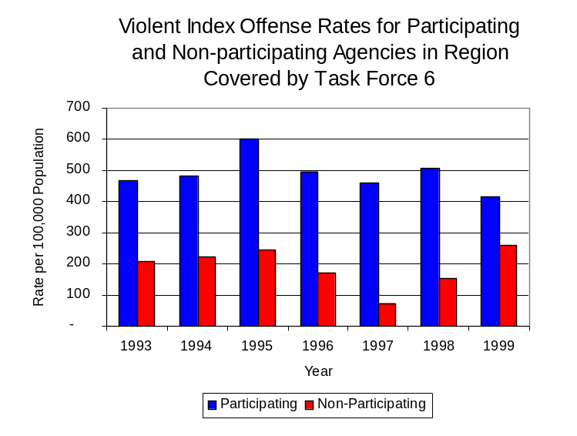
During the period analyzed, the violent Index offense rate for the region covered by Task Force 6 decreased 8 percent, from 426 offenses per 100,000 population in 1993 to 393 offenses per 100,000 population in 1999. Similarly, the violent Index offense rate in the participating agencies decreased 11 percent, from 468 to 416 offenses per 100,000 population, while the rate in the non-participating agencies increased 24 percent, from 208 to 257 offenses per 100,000 population (Figure 1). Thus, while the violent Index offense rate was collectively higher across the jurisdictions that participated in Task Force 6 than it was among the combined jurisdictions that did not participate in Task Force 6. The violent Index offense rate has decreased during the period analyzed in those agencies that participate in Task Force 6, while increasing in those agencies that do not participate in Task Force 6.
Source: ICJIA calculations using
Illinois State Police and U.S. Census Bureau data
Figure 1

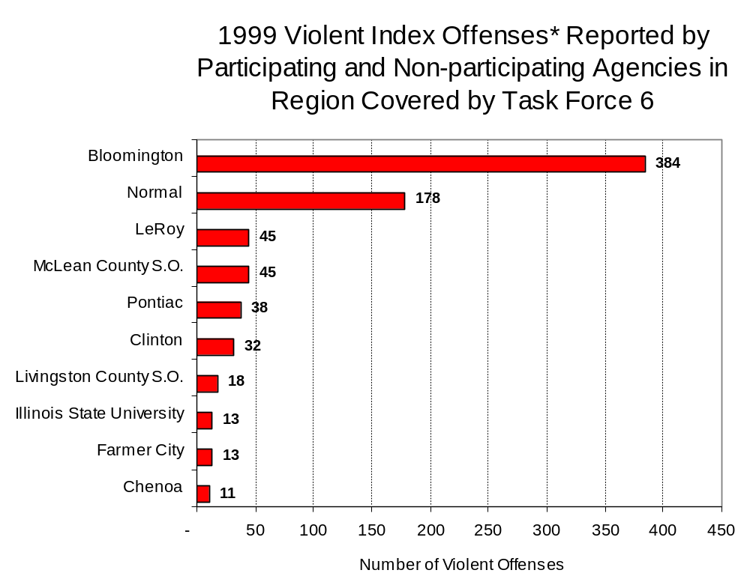
Across the 22 individual local law enforcement agencies covered by Task Force 6’s jurisdiction, two agencies, the Bloomington Police Department and the Normal Police Department, accounted for 70 percent of all violent offenses reported to the police (Figure 2). Nine agencies had fewer than 11 violent offenses reported in 1999 and are excluded from Figure 2. When controlling for differences in the populations served by these law enforcement agencies, the violent Index offense rate ranged from zero in four agencies to 1,460 offenses per 100,000 population reported by authorities in LeRoy.
Source: Illinois State Police *Agencies reporting ten or more violent offenses
Figure 2

An indicator of the workload that law enforcement agencies place on other components of the justice system is the number of arrests made by police, including those for violent and property Index offenses and drug offenses. Unlike offenses, which are what police must respond to, arrests represent those offenders who may eventually be processed through other components of the justice system, including the courts, county jails, and state and local correctional programs.

Between 1993 and 1999, the number of arrests for violent Index offenses made by law enforcement agencies in the region covered by Task Force 6 decreased two percent, from 456 to 447. As with reported violent Index offenses, the majority (88 percent) of violent Index arrests were for aggravated assaults, followed by criminal sexual assaults (7 percent).

During the period analyzed, the violent Index arrest rate for the region covered by Task Force 6 decreased 7 percent, from 237 offenses per 100,000 population in 1993 to 222 arrests per 100,000 population in 1999. Similarly, the violent Index arrest rate in the participating agencies decreased 10 percent, from 248 to 223 offenses per 100,000 population, while the rate in the non-participating agencies increased 17 percent, from 183 to 213 offenses per 100,000 population (Figure 3).

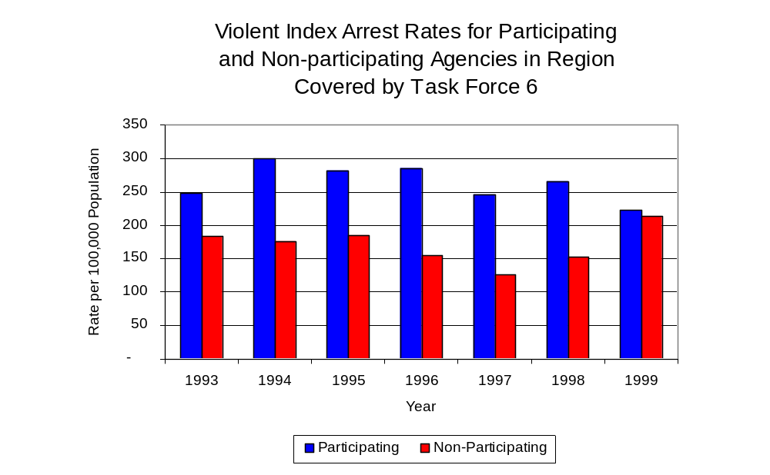
The majority (68 percent) of arrests for violent Index offenses occurring in the three-county region covered by Task Force 6 were made by two agencies. Twelve agencies had fewer than 15 arrests for violent Index offenses reported in 1999 and are excluded from Figure 4. Of the 440 violent Index arrests made in 1999, the Bloomington Police Department accounted for the majority (50 percent), followed by the Normal Police Department (18 percent) (Figure 4).
Figure 3
Source: ICJIA calculations using
Illinois State Police and U. S. Census Bureau data

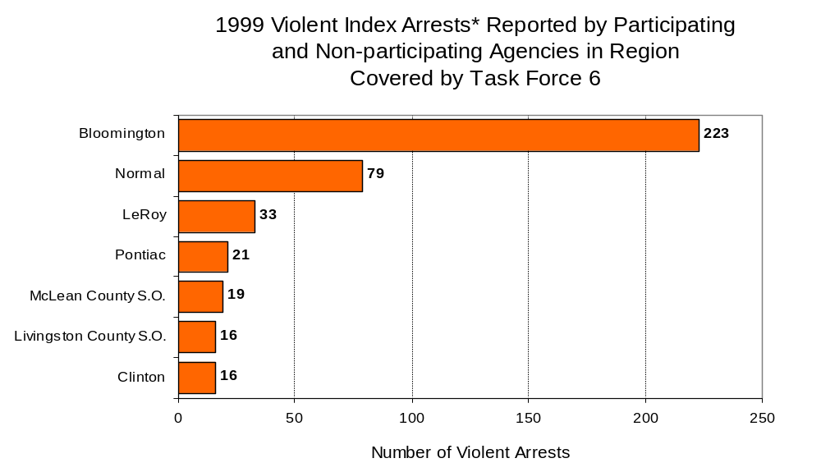
Figure 4
Source: Illinois State Police *Agencies reporting 15 or more violent offenses
III. Trends in Drug Arrests

There are two sources of drug arrest data presented in this section. One source is the Illinois Uniform Crime Reporting (I-UCR) program that includes information submitted by local law enforcement agencies on the number of persons arrested for violations of Illinois’ Cannabis Control Act, Controlled Substances Act, Hypodermic Syringes and Needles Act, and Drug Paraphernalia Control Act. In addition, data on drug arrests made by Illinois’ MEGs and task forces are reported to the Illinois Criminal Justice Information Authority. In some jurisdictions, arrests made by the MEG or task force may be reported by both local law enforcement agencies through the I-UCR and to the Authority by the unit. In other jurisdictions, arrests made by the MEG or task force are only reported to the Authority by the unit. Therefore, in some instances drug arrests may be double counted – included in both local agency statistics reported to I-UCR and those of the MEG or task force. Currently there is no mechanism in place to ensure that drug arrest statistics are not being duplicated at both the local agency and MEG/task force level. This should be kept in mind when interpreting the information presented in the following section.

The majority of drug offenses in Illinois are violations of either the Cannabis Control Act – which prohibits the possession, sale and cultivation of marijuana – or the Controlled Substances Act – which prohibits the possession, sale, distribution or manufacture of all other illegal drugs, such as cocaine and opiates. Illinois also has various other laws prohibiting other drug-related activity. These include the Hypodermic Syringes and Needles Act – which prohibits the possession or sale of hypodermic instruments – and the Drug Paraphernalia Control Act – which prohibits the possession, sale or delivery of drug paraphernalia. In general, violations of Illinois Controlled Substances Act are considered to be more serious, since they primarily involve cocaine, heroin, methamphetamine, and hallucinogens, and are almost all classified under Illinois law as felonies. The majority of cannabis and drug paraphernalia offenses encountered by police, on the other hand, tend to be misdemeanor-level offenses.

In 1999, local law enforcement agencies in the counties covered by Task Force 6 reported 1,649 arrests for drug law violations, more than quadruple the number reported for 1993 (357 arrests). Between 1993 and 1999, arrests for violations of Illinois’ Cannabis Control Act consistently out-numbered arrests for violations of the Controlled Substances Act in DeWitt, Livingston and McLean counties, combined. During the same period, the number of arrests for violations of the Cannabis Control Act in these three counties, combined, almost tripled, from 252 to 705. Arrests for violations of the Controlled Substances Act in the three-county region increased almost three-fold, from 92 to 331. In addition, arrests for violations of the Drug Paraphernalia Control Act, enacted in 1993, increased from ten in 1993 to 608 in 1999. Much of this increase can be attributed to a 1994 addition to the Drug Paraphernalia Control Act, which included the possession of drug paraphernalia as a violation.

Because arrests for violations of the Drug Paraphernalia Control Act are frequently made in conjunction with other drug offense arrests, these arrests may be double-counted, thus skewing the actual number of drug arrests. Therefore, only arrests for violations of the Cannabis Control Act and Controlled Substances Act will be used for drug arrest comparisons between Task Force 6 and the participating and non-participating agencies.

During the period analyzed, the drug arrest rate for the Cannabis Control and Controlled Substances Acts combined, in the region covered by Task Force 6 nearly tripled, from 179 arrests per 100,000 population in 1993 to 514 arrests per 100,000 population in 1999. Similarly, the drug arrest rate in the participating agencies increased from 193 to 553, while the drug arrest rate for non-participating agencies increased from 107 to 285 arrests per 100,000 population. Conversely, the arrest rate for Task Force 6 decreased 58 percent, from 36 to 15 arrests per 100,000 population (Figure 5). Thus, the drug arrest rate tended to be higher collectively in the jurisdictions that participate in Task Force 6 than in those jurisdictions that do not participate in Task Force 6.

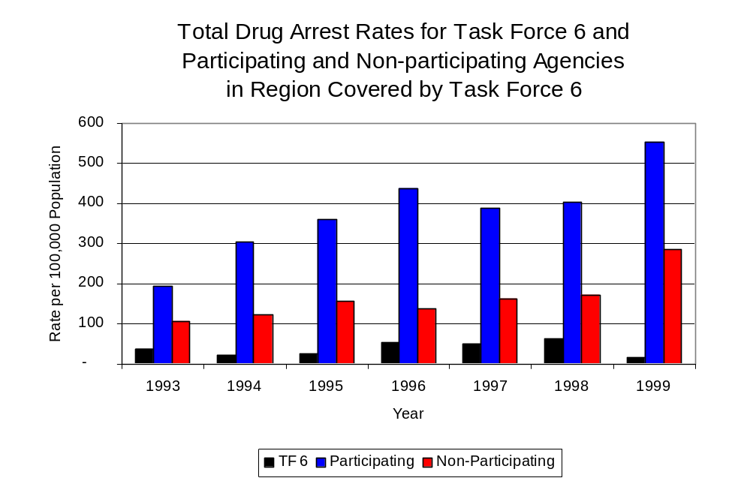
Across the individual local law enforcement agencies in the region covered by Task Force 6, the total number of cannabis and controlled substance arrests ranged from zero to 457. Of the 1,036 drug arrests made during 1999 in the three-county region, two agencies accounted for 74 percent of these drug arrests. Nine agencies had fewer than 15 drug arrests reported in 1999 and are excluded from Figure 6. The Bloomington Police Department accounted 44 percent, while the Normal Police Department accounted for 30 percent of cannabis and controlled substance arrests in the three-county region covered by Task Force 6 (Figure 6). Seven of the eight agencies participating in Task Force 6 were among the ten agencies with the highest number of drug arrests during 1999.
Source: ICJIA calculations using Illinois State Police, Task Force 6 and U.S. Census Bureau data
Figure 5
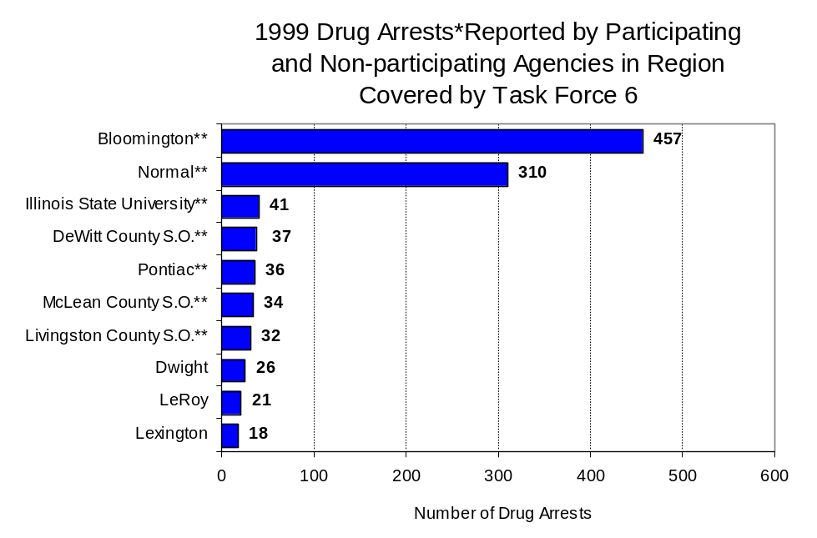
Figure 6
Source: Illinois State Police *Agencies reporting 15 or more drug arrests
**Agencies participating in Task Force 6

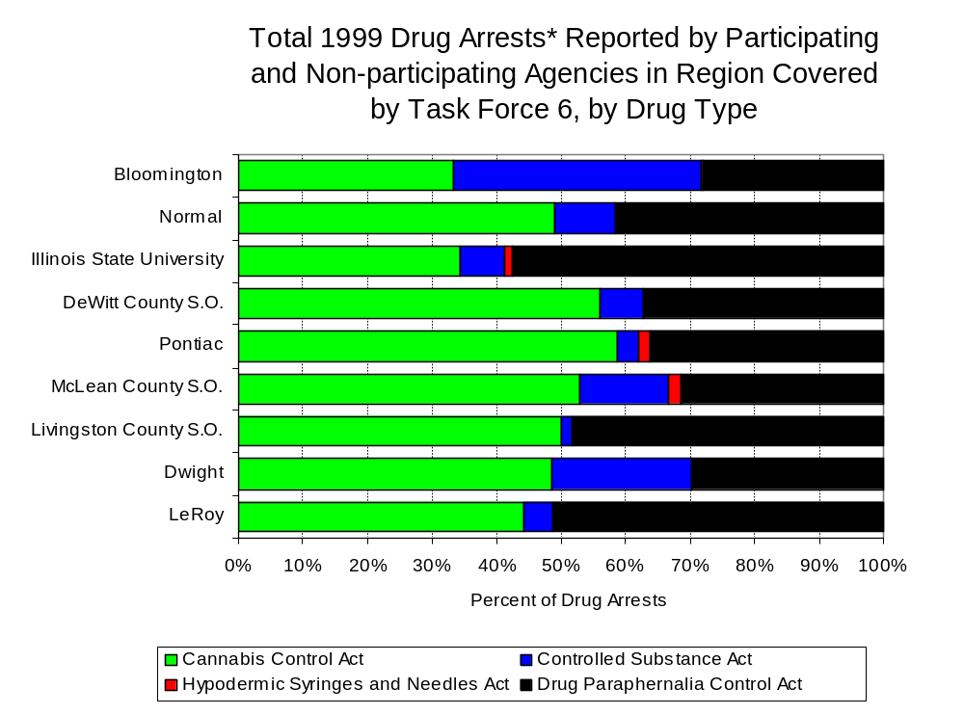
In addition to the difference in the number of drug arrests made, there are also differences in the types of drug law violation arrests across the agencies in the region. In 1999, violations of the Cannabis Control Act and the Drug Paraphernalia Control Act accounted for the majority of arrests across most individual agencies in the region covered by Task Force 6 (Figure 7).
Figure 7
Source: Illinois State Police *Agencies reporting 20 or more drug arrests

Between 1993 and 1999, the number of combined cannabis and controlled substances arrests made by Task Force 6 decreased 55 percent, from 58 to 26 (Figure 8). Unlike drug arrests made by most local police departments in the region, violations of the Controlled Substances Act accounted for the majority of drug arrests made by Task Force 6 during the period analyzed. Between 1993 and 1999, the number of Task Force 6 arrests for violations of the Cannabis Control Act decreased 28 percent, from 18 to 13, and arrests for violations of the Controlled Substances Act decreased 68 percent, from 40 to 13 (Figure 8).

Between 1993 and 1999, the proportion of drug arrests made by Task Force 6 accounted for by violations of the Controlled Substances Act decreased 28 percent between 1993 and 1999. In 1999, one-half of the drug arrests made by Task Force 6 were for violations of the Controlled Substances Act, compared to 69 percent in 1993. In 1999, arrests for violations of the Controlled Substances Act accounted for one-third of the drug arrests made in the participating agencies and 17 percent for the non-participating agencies, compared to 29 percent and 3 percent, respectively, in 1993. Thus, arrests by Task Force 6 were more likely than arrests by either participating or non-participating agencies to involve violations of Illinois’ Controlled Substances Act, as opposed to the Cannabis Control Act. One interpretation of this pattern is that Task Force 6 is more focused in who they are targeting and arresting than local departments, and are also getting a more serious drug law violator, since violations of the Controlled Substances Act are more likely to involve felony-level offenses.

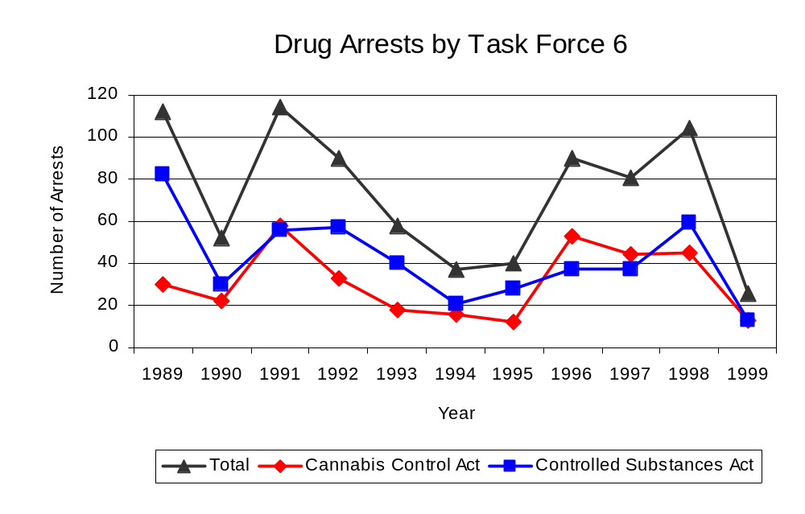
The data presented below represent the percent of total drug arrests made by participating agencies accounted for by Task Force 6. An upper and lower bound is shown in Figure 9 which accounts for whether or not the units numbers are counted as part of the UCR submissions made by local departments (which is unknown at this point). The upper bound indicates the percentage of arrests if all of the Task Force 6 arrests are included in the local UCR submissions. The lower bound indicates the percentage if none of the Task Force 6 arrests are included in the local UCR submissions. It is estimated that the proportion of all drug arrests across the participating agencies accounted for by Task Force 6 was between 16 to 19 percent in 1993, but decreased to 3 percent in 1999. Thus, despite the fact that the officers assigned to Task Force 6 accounted for a small proportion of total officers in the region, they accounted for a relatively moderate proportion of the drug arrests in the region between 1993 and 1998.
Source: Task Force 6
Figure 8

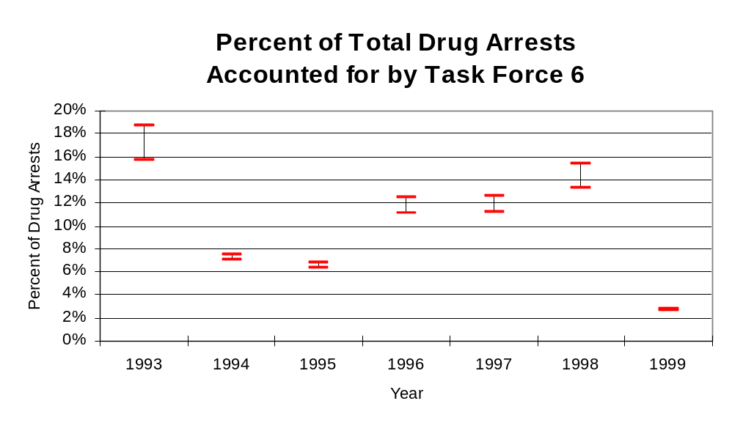
Figure 9
Source: ICJIA calculations using
Illinois State Police and Task Force 6

The number of arrests for violations of Illinois’ Cannabis Control Act in DeWitt, Livingston and McLean counties totaled 705 in 1999, almost triple the 252 arrests made for cannabis violations in 1993. Between 1993 and 1999, the proportion of all drug arrests accounted for by violations of the Cannabis Control Act in the three-county region decreased 8 percent, increasing from 74 percent to 68 percent. Agencies participating in Task Force 6 accounted for the largest portion (90 percent) of the total number of arrests for cannabis violations. Task Force 6 reported 13 arrests for cannabis violations in 1999, one-half of the unit's drug arrests.

During the period analyzed, the cannabis arrest rate for the region covered by Task Force 6 more than doubled, from 131 arrests per 100,000 population in 1993 to 350 arrests per 100,000 population in 1999. The cannabis arrest rate in the participating agencies also more than doubled, from 138 to 370 arrests per 100,000 population, while the arrest rate in the non-participating agencies more than doubled from 98 to 234 arrests per 100,000 population. The cannabis arrest rate for Task Force 6, on the other hand, decreased 33 percent, from 11 to eight arrests per 100,000 population (Figure 10). Thus, the arrest rate for violations of the Cannabis Control Act was collectively higher in the area served by participating agencies than in the combined jurisdictions of the non-participating agencies.
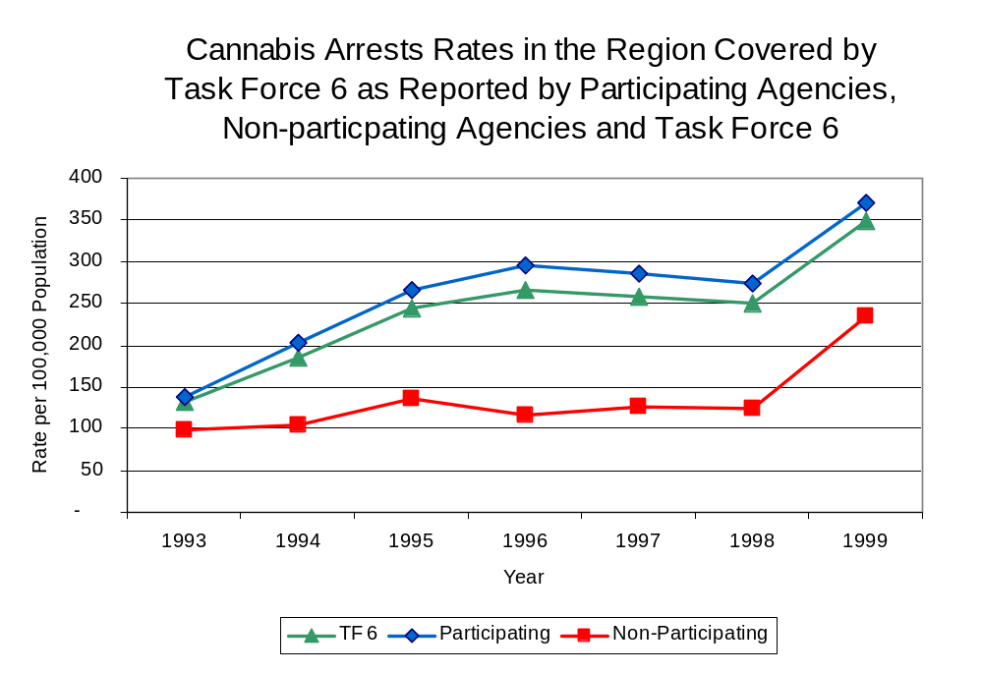
Source: ICJIA calculations using
Illinois State Police and Task Force 6 data
Figure 10

The data presented in Figure 11 represent the percent of cannabis arrests made by participating agencies accounted for by Task Force 6. An upper and lower bound is shown which accounts for whether or not the unit’s numbers are counted as part of the UCR submissions made by local departments (which is unknown at this point). The upper bound indicates the percentage of arrests if none of the Task Force 6 arrests are included in the local UCR submissions. The lower bound indicates the percentage if all of the Task Force 6 arrests are included in the local UCR submissions. It is estimated that the proportion of cannabis arrests across the participating agencies accounted for by Task Force 6 was about 8 percent in 1993, but decreased to 2 percent in 1999.

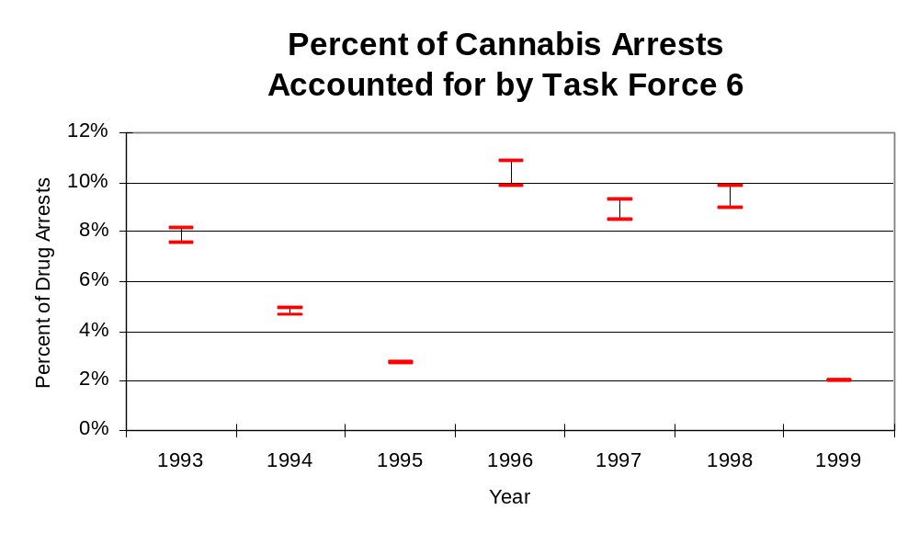
In DeWitt, Livingston and McLean counties, the number of arrests for violations of Illinois’ Controlled Substances Act increased nearly four-fold between 1993 and 1999, from 90 to 330. Between 1993 and 1999, the proportion of all drug arrests accounted for by violations of the Controlled Substances Act in the three-county region increased from 26 percent to 32 percent. In 1999, Task Force 6 reported 13 arrests for controlled substance violations, one-half of all drug arrests reported to the Authority by the unit.
Figure 11
Source: ICJIA calculations using
Illinois State Police and Task Force 6 data

Between 1993 and 1999, the arrest rate for controlled substances act violations for the region covered by Task Force 6 more than tripled, from 47 to 164 arrests per 100,000 population (Figure 12). The controlled substances arrest rate in the participating agencies also more than tripled, from 56 to 184 arrests per 100,000 population, while the arrest rate in the non-participating agencies increased more than 14-fold, from three to 47 arrests per 100,000 population. The controlled substances arrest rate for Task Force 6 decreased 70 percent, from 25 to eight arrests per 100,000 population (Figure 12). Thus, the Controlled Substances Act arrest rate was significantly higher in the participating agencies than the non-participating agencies.

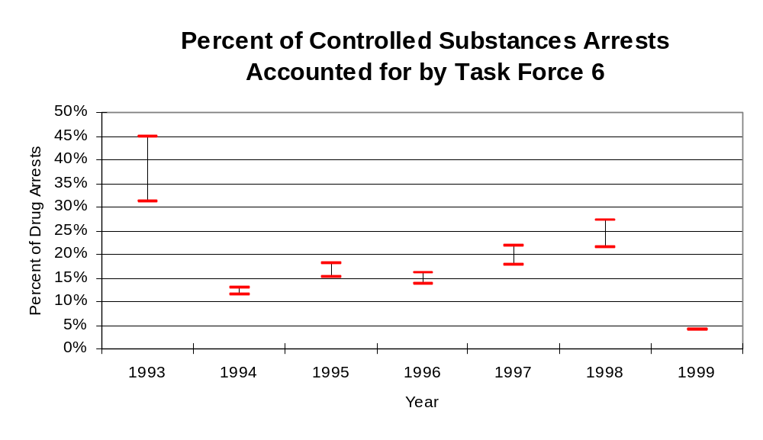
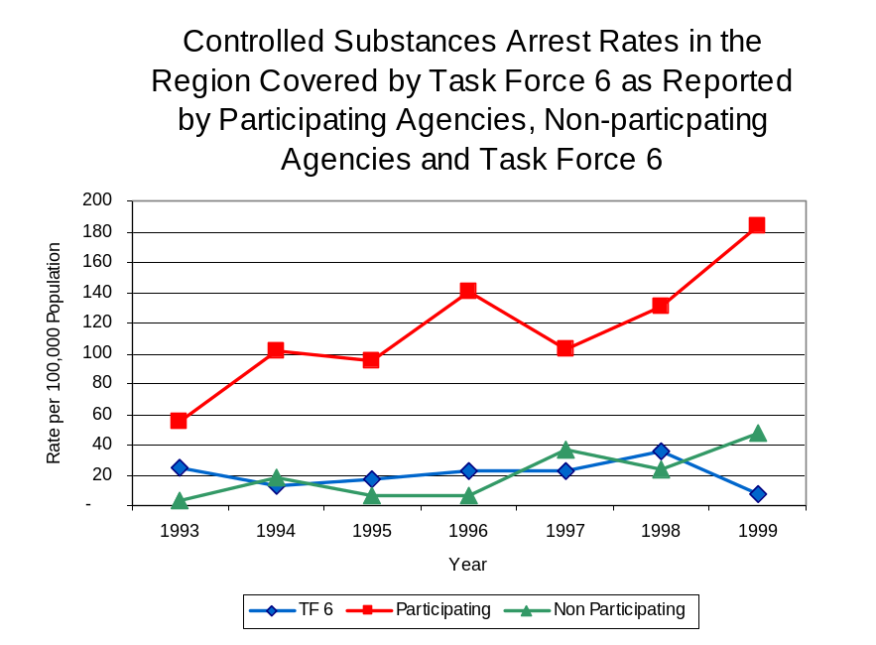
The data presented in Figure 13 represent the percent of controlled substances arrests made by participating agencies accounted for by Task Force 6. An upper and lower bound is shown which accounts for whether or not the units numbers are counted as part of the UCR submissions made by local departments (which is unknown at this point). The upper bound indicates the percentage of arrests if all of the Task Force 6 arrests are included in the local UCR submissions. The lower bound indicates the percentage if none of the Task Force 6 arrests are included in the local UCR submissions. It is estimated that the proportion of controlled substances arrests across the participating agencies accounted for by Task Force 6 was between 31 to 45 percent in 1993, but decreased to 4 percent in 1999.
Figure 13
Source: ICJIA calculations using
Illinois State Police and Task Force 6 data
Figure 12
Source: ICJIA calculations using Illinois State Police and Task Force 6 data
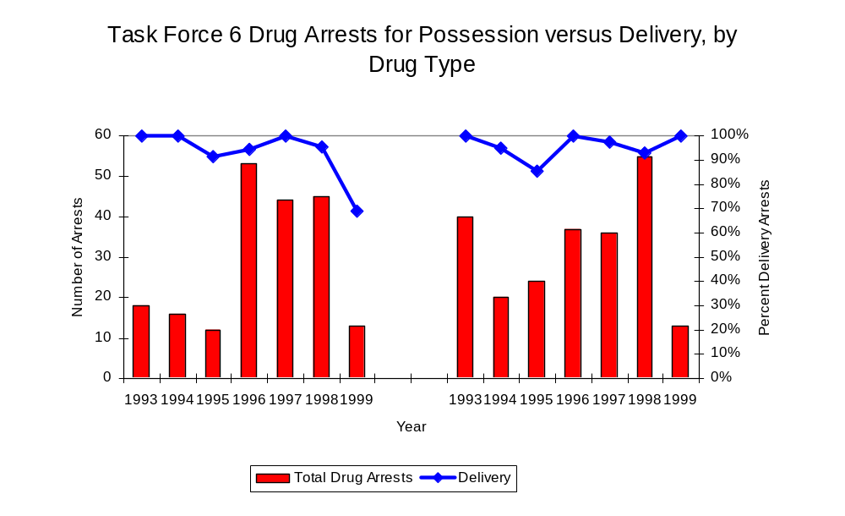
The majority of all drug arrests reported by Task Force 6 are for delivery. Arrests for drug delivery accounted for 98 percent of all drug arrests made by Task Force 6 between 1993 and 1999. When cannabis and controlled substance arrests were examined separately, during the period analyzed, arrests for delivery of controlled substances accounted for 96 percent of the total number of arrests made for violations of the Controlled Substance Act. Similarly, arrests for the delivery of cannabis accounted for 93 percent of all arrests for violations of the Cannabis Act. Despite a decrease in the number of drug arrests for violations of the Cannabis Control and Controlled Substances Acts during the period analyzed, drug delivery arrests accounted for a relatively stable proportion of all drug arrests made by Task Force 6. Between 1993 and 1998, the proportion of arrests for delivery of cannabis ranged from 91 to 100 percent of all arrests made for violations of the Cannabis Control Act, before dropping to 62 percent in 1999. Arrests for the delivery of controlled substances ranged from 86 to 100 percent of all arrests made for violations of the Controlled Substances Act during the period analyzed.
Figure 14
Source: ICJIA calculations using Task Force 6 data
Cannabis Control Act

Controlled Substances Act

IV. Trends in Drug Seizures

Drugs seized by law enforcement agencies are another indicator of the extent and nature of illegal drug trade in a jurisdiction. When illegal drugs are seized by law enforcement agencies, all or a portion of the total amount seized is submitted to a crime lab for analysis. Most agencies submit drugs to one of the Illinois State Police crime labs. These labs record the quantity of drugs submitted from each county. This section discusses trends in the quantities of illegal drugs seized and submitted to the Illinois State Police from local law enforcement agencies in DeWitt, Livingston and McLean counties as well as the quantities of drugs seized by Task Force 6. It is important to note, however, that while Task Force 6 data report the total quantities of drugs actually seized, local agency data only represent the quantities of seized drugs that are submitted to the Illinois State Police for analysis. County-level cannabis, cocaine and methamphetamine seizure rates for Illinois' 102 counties are provided in maps located in the Appendix of this report.

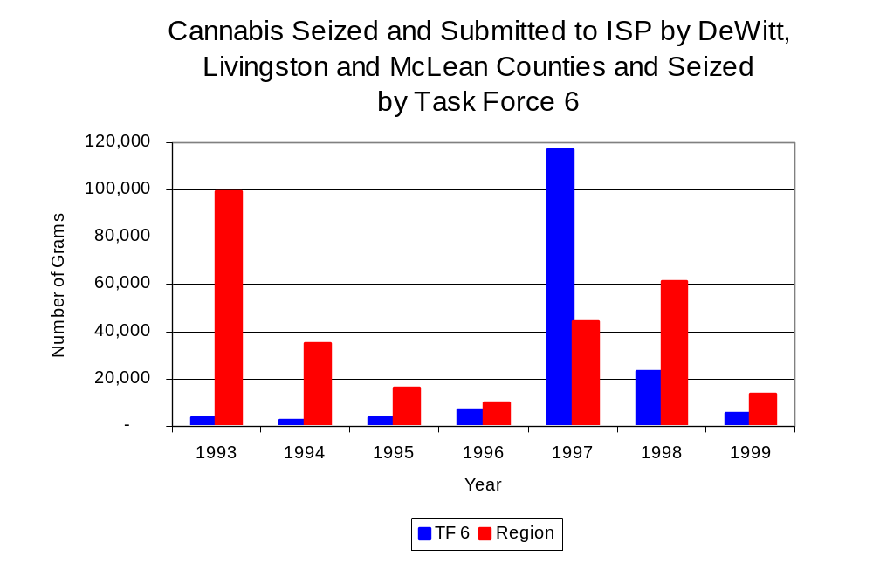
As in most Illinois jurisdictions, cannabis accounts for the majority of illegal drugs seized in the three-county region covered by Task Force 6. The quantity of cannabis seized and submitted by law enforcement agencies in DeWitt, Livingston and McLean counties decreased 86 percent, from 99,461 grams in 1993 (the largest amount seized during the period analyzed) to 14,029 grams in 1999. However, the quantity of cannabis seized by Task Force 6 increased 59 percent between 1993 and 1999, from 3,443 grams to 5,479 grams. The largest amount seized by Task Force 6 was in 1996 (23,500 grams seized) (Figure 15). In 1999, Task Force 6's cannabis seizure rate of 3,184 grams per 100,000 population was significantly lower than the statewide cannabis seizure rate of 31,533 grams per 100,000 population, and 54 percent lower than the seizure rate of 6,958 grams per 100,000 population in the three-county region covered by Task Force 6 (Map 2).
Figure 15
Source: Illinois State Police and Task Force 6

Between 1993 and 1999, a combination of crack and powder cocaine has accounted for a small proportion of drugs seized in the three-county region covered by Task Force 6. The quantity of cocaine seized and submitted by law enforcement agencies in DeWitt, Livingston and McLean counties decreased 44 percent, from 2,115 grams in 1993 to 1,178 grams in 1999. Between 1993 and 1999, the quantity of cocaine seized by Task Force 6 increased nearly six-fold, from 116 grams to 730 grams, while seizing 15,769 grams in 1996.

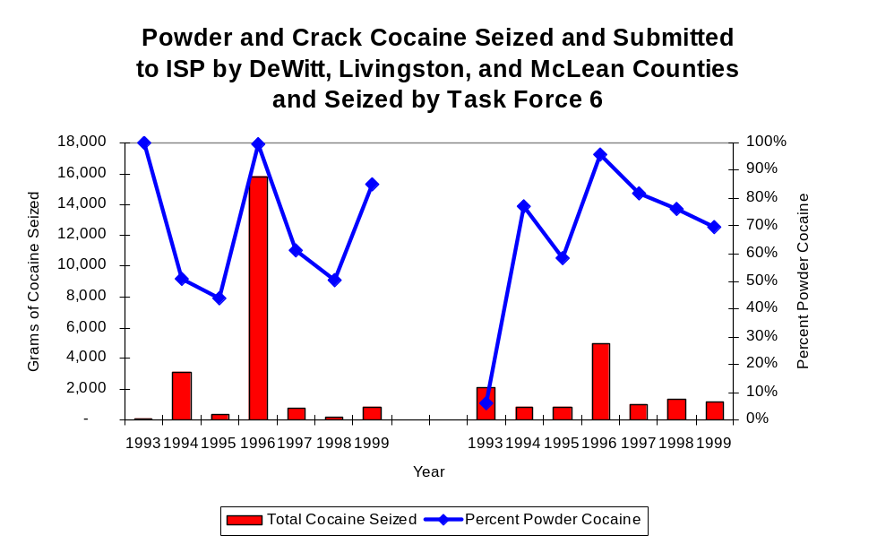
The proportion of all cocaine seized by Task Force 6 accounted for by powder cocaine varied significantly between 1993 and 1999, whereas local seizures, with the exception of 1993, appeared to be somewhat more stable. Although accounting for nearly two-thirds of cocaine seized during the period analyzed, the proportion accounted for by powder cocaine ranged from 6 to 96 percent of the cocaine seized in the three-county region covered by Task Force 6. For Task Force 6, while powder cocaine accounted for the largest proportion (70 percent) of total cocaine seizures throughout most of the period, the proportion decreased from 100 percent in 1993 to 85 percent in 1999 (Figure 16). In 1999, Task Force 6's cocaine seizure rate of 424 grams per 100,000 population was 27 percent less than the cocaine seizure rate of 584 grams per 100,000 population in the three-county region covered by Task Force 6. It was also significantly less than the statewide cocaine seizure rate of 15,735 grams per 100,000 population (Map 3).
Figure 16
Source: Illinois State Police and Task Force 6
TF 6
Region

The total quantity of illegal drugs seized and submitted by law enforcement agencies in DeWitt, Livingston and McLean counties decreased 84 percent between 1993 and 1999, from a high of 101,646 grams to 15,975 grams. On the other hand, the total quantity of illegal drugs seized by Task Force 6 increased 76 percent, from 3,713 grams in 1993 to 6,543 grams in 1999.

During the period, methamphetamine seizures accounted for a relatively small proportion of total drugs seized by Task Force 6 and the region covered by Task Force 6. Between 1994 and 1999, there were 15 grams of methamphetamine seized by law enforcement agencies in the three-county region covered by Task Force 6. Task Force 6, on the other hand, did not seize any methamphetamine during the entire period. In 1999, the three-county region covered by Task Force 6 had a methamphetamine seizure rate of less than one gram per 100,000 population, significantly lower than the statewide seizure rate of 98 grams per 100,000 population (Map 4).

Trends in Prosecutions for Drug Offenses and All Felonies

Although Illinois has one of the best court reporting systems in the country, the Administrative Office of the Illinois Court only collects information regarding the aggregate number of court filings. Currently, there are no statewide data available on court filings by offense type. The Administrative Office of the Illinois Courts reports data on felony criminal court cases. After screening a case and deciding it warrants further action, the state’s attorney must file formal charges in court. Felony cases can be punished by a probation term up to four years and incarceration for more than one year.

Between 1989 and 1999, the number of felony filings in the three-county region covered by Task Force 6 increased nearly every year. The number of felony filings increased 62 percent, from 1,094 to 1,775 (Figure 17).

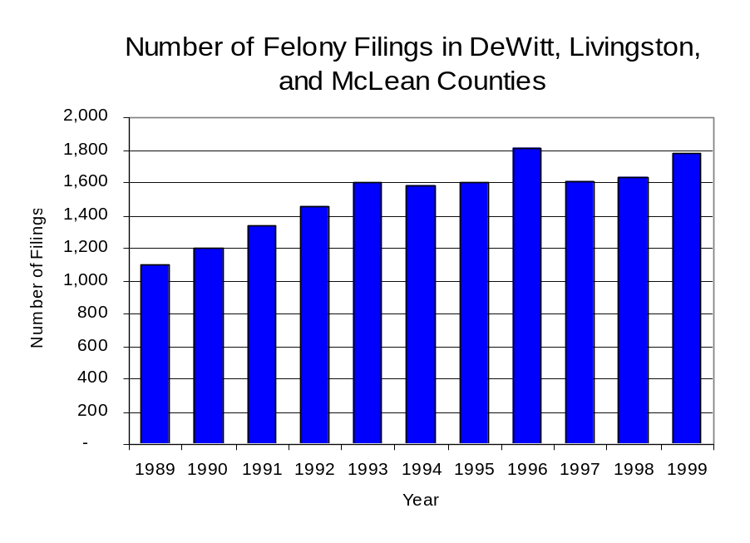
Figure 17
Source: Administrative Office of the Illinois Courts

Between 1989 and 1999, there were a total of 683 drug prosecutions initiated as a result of Task Force 6 arrests in DeWitt, Livingston and McLean counties. During this time, the number of Task Force 6 drug arrests decreased 77 percent, from 112 arrests in 1989 to 26 arrests in 1999. Between 1991 and1999, 85 percent of Task Force 6 drug arrests resulted in prosecution. Of those offenders prosecuted, 58 percent were prosecuted for a violation of the Controlled Substances Act. In some years, the proportion of arrests resulting in a prosecution exceeded 100 percent (Figure 18). This is due to some slight differences in the timing of an arrest and the filings of charges, or could be due to charges, rather than defendants, being reported by the unit. In addition, some offenders have charges filed, and a subsequent warrant issued, without an arrest taking place.

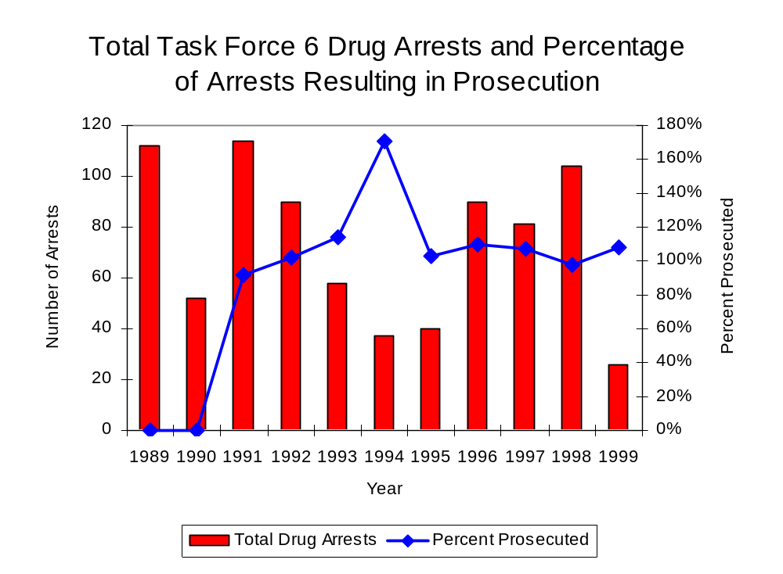
Figure 18
Source: Task Force 6

Between 1989 and 1999, 67 percent (461) of the 683 drug offenders who were prosecuted as a result of Task Force 6 activity were convicted. Convictions for controlled substances accounted for 59 percent of all Task Force 6 initiated convictions during the period analyzed.

VI. Trends in Percent of Convicted Drug Offenders Sentenced to Prison

Anyone convicted of a felony in Illinois can be sentenced either to prison or probation, or receive conditional discharge. A number of factors influence the type and length of sentence imposed on convicted felons, including the severity of the crime, the offender’s criminal and social history, safety of the community and legislation affecting certain types of offenses. For some types of convictions, a sentence to prison is required by state statute.

Between 1989 and 1999, the number of offenders convicted of a felony and sentenced in the three-county region covered by Task Force 6 nearly doubled, from 657 to 1,144. Although the number of convicted felons sentenced to the Illinois Department of Corrections (IDOC) increased 45 percent between 1989 and 1999, from 332 to 482, the proportion of felons sentenced to IDOC decreased during the same period, from 51 percent to 42 percent of total felony sentences. In 1999, 645 probation sentences were imposed on convicted felons, more than doubled the number of probation sentences in 1989 (Figure 19). As a result, the proportion of felons sentenced to probation increased from 49 percent in 1989 to 56 percent in 1999. Sentences other than prison or probation account for the remaining 2 percent of felony sentences imposed in 1999.
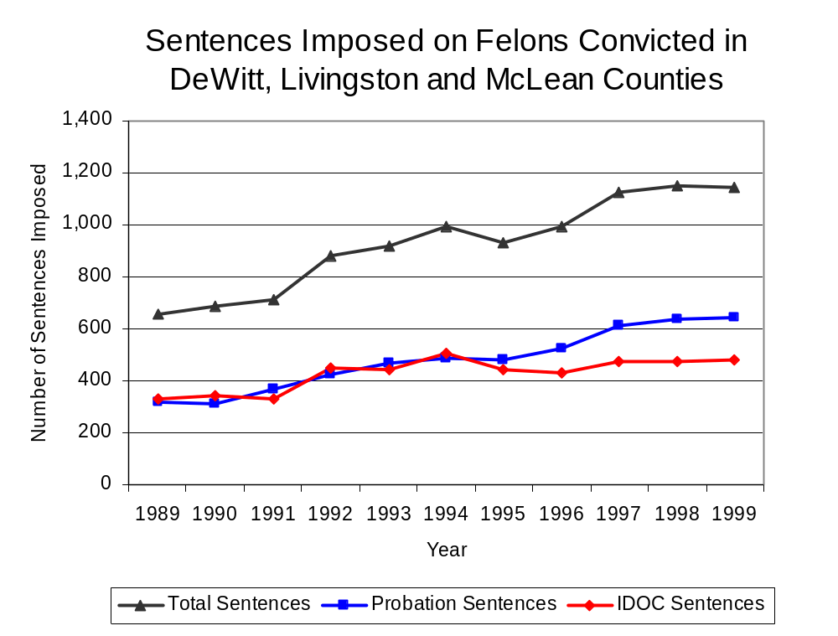
Figure 19
Source: Administrative Office of the Illinois Courts

During the period analyzed, the number of Task Force 6 drug offenders convicted and sentenced varied, increasing from zero in 1989 to a period high of 102 in 1992 to 49 in 1999. Between 1989 and 1999, the number of convicted Task Force 6 drug offenders sentenced to probation increased from zero in 1989 to six in 1999, although in 1991 and 1992, the number of convicted Task Force 6 drug offenders sentenced to probation reached an all time high of 12. Similarly, the number of convicted Task Force 6 drug offenders sentenced to jail increased from zero to 16 (42 were sentenced to jail in 1992). The number of drug offenders sentenced to prison increased from zero to 27 (48 were sentenced to prison in 1992) (Figure 20). In 1999, among those Task Force 6 drug offenders convicted and sentenced, prison sentences accounted for the largest proportion (55 percent), followed by jail sentences (33 percent) and probation sentences (12 percent).

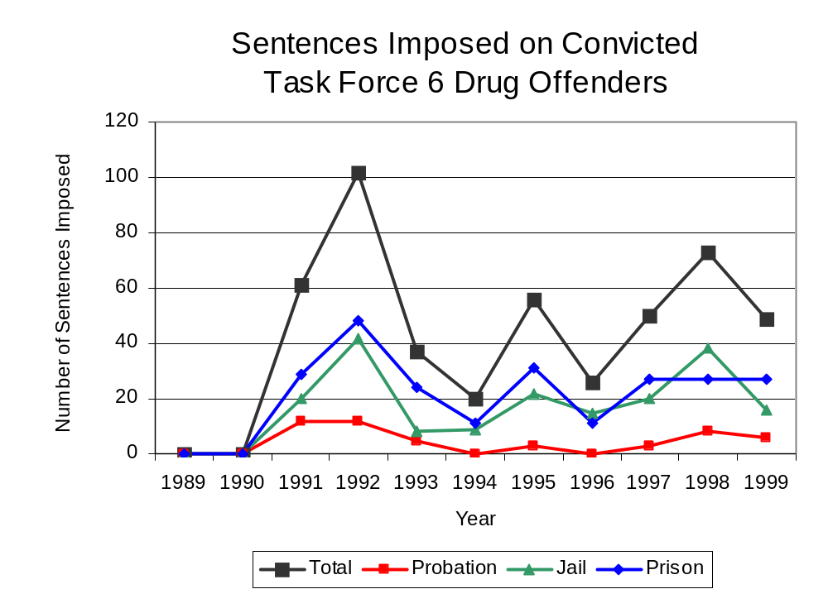
Figure 20
Source: Task Force 6

Between state fiscal years 1990 and 1999, the number of new court commitments to IDOC’s Adult Division for drug offenses from the three-county region covered by Task Force 6 nearly tripled, from 47 to 123. The number of drug offender admissions by Task Force 6 also increased from zero to 19 between 1990 and 1999, while experiencing a period high of 50 commitments in 1992 (Figure 21). Thus, during the period analyzed, prison sentences resulting from Task Force 6 cases accounted for more than one-quarter (27 percent) of all drug-law violators sentenced to prison from the three-county region where Task Force 6 operates.

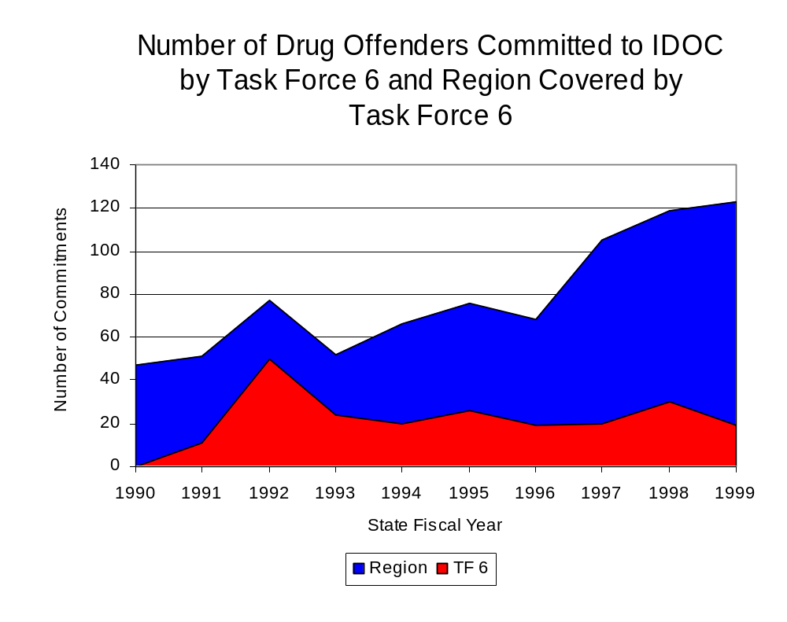
Figure 21
Source: Illinois Department of Corrections and Task Force 6

During the period analyzed, drug offenders accounted for an increasing proportion of adults convicted and sentenced to prison from DeWitt, Livingston and McLean counties. In 1989, drug offenses accounted for 18 percent of all commitments to IDOC, compared to 30 percent in 1999 (Figure 22).

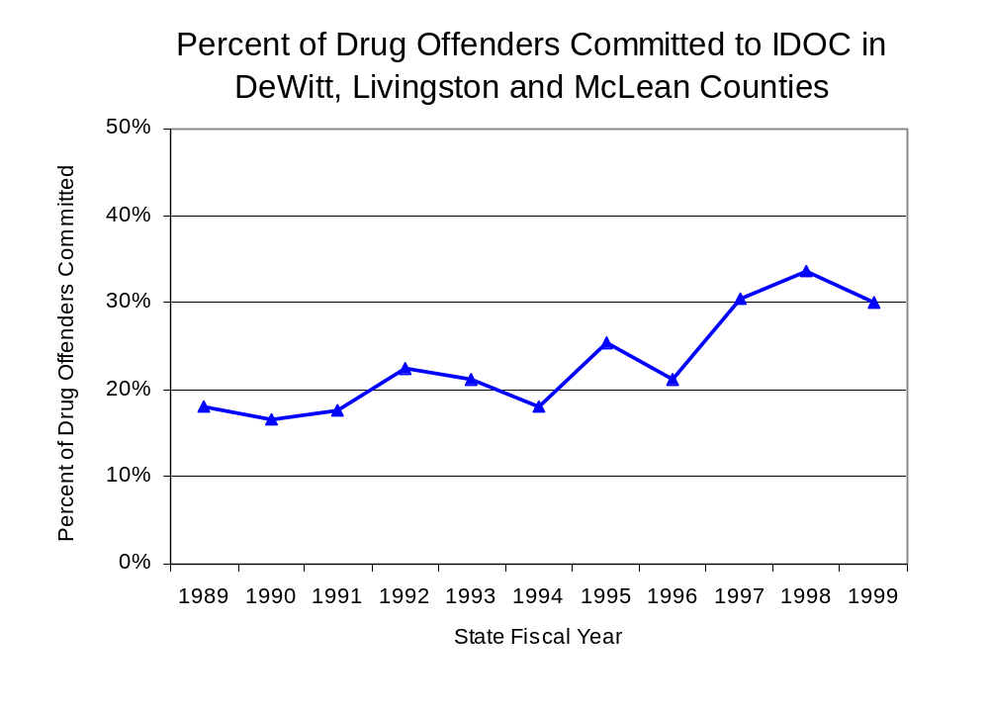
Figure 22
Source: Illinois Department of Corrections

Penalties for drug offenses were also examined between 1993 and 1999. Class 1 and Class 2 felonies accounted for the largest proportion (29 percent) of sentences to IDOC for drug offenses, followed by Class 4 felonies (22 percent), Class X felonies (11 percent) and Class 3 (9 percent). Between 1993 and 1999, the number of Class 4 felony sentences increased more than three-fold, from seven to 29. The number of Class 1 felony more than tripled, from 13 to 44, while Class 2 felony sentences more than doubled, from 15 to 31. The number of Class X felonies increased 43 percent, from seven to ten. Although the number of Class 3 felony sentences varied during the period, the number of Class 3 felony sentences decreased slightly, from ten in 1993 to nine in 1999 (Figure 23).

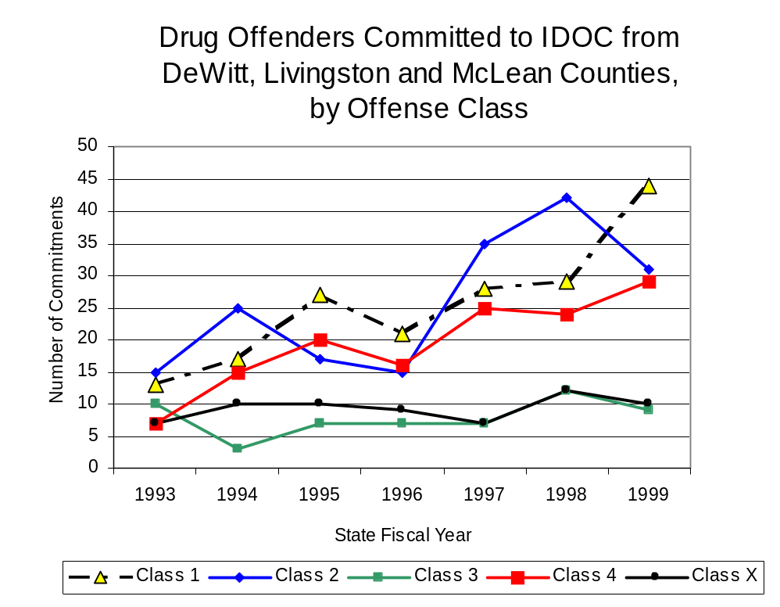
When analyzing the mean sentence length for felony offenders between 1993 and 1999, the most dramatic change was for Class 2 felonies, which increased 21 percent, from 3.8 to 4.6 years. The mean sentence length for Class 3 felonies also increased, but only slightly (from 3.15 to 3.17 years). Mean sentence lengths for Class X, Class 4 and Class 1 felonies all decreased during the period analyzed. The mean sentence length for Class X felonies decreased 7 percent (9.74 to 9.05 years), Class 4 sentence lengths decreased 4 percent (2.57 to 2.47 years) and Class 1 sentence lengths decreased less than 2 percent (from 5.92 to 5.83 years).
Figure 23
Source: Illinois Department of Corrections

Based on data collected from the 2000 Illinois Adult Probation Outcome Study, just over 10 percent (10.2 percent) of all adults discharged from probation in DeWitt, McLean, and Livingston counties combined during the study period (November 2000) were convicted of drug-law violations. Of these drug-law violators discharged from probation in the region, more than three-quarters (83.3 percent) had been convicted of a felony drug offense. In addition, more than three-quarters (87.5 percent) of these drug-law violators were ordered to participate in some form of treatment.

VII. Trends in Drug Treatment Admissions in Task Force 6 Region by Drug Type

In addition to considering indicators of the extent and nature of drug abuse as reported through the criminal justice system (for example, arrests and prison sentences), there are indicators of substance abuse available from other Illinois social service agencies. Overseeing and supporting treatment for substance users, whether they are referred from the criminal justice system or elsewhere, is the responsibility of the Illinois Department of Human Services’ Office of Alcoholism and Substance Abuse (OASA). It is important to note, however, that while OASA data represent the majority of the overall demand for substance abuse treatment in the state, some private programs provide treatment services to a smaller but significant number of clients who may not be included in the state’s reporting system.

In state fiscal year 1999, OASA reported 1,279 admissions for alcohol or drug abuse treatment from DeWitt, Livingston and McLean counties, 9 percent more than the 1,178 admissions in 1989 (Figure 24). Among the 1,279 admissions to substance abuse treatment in state fiscal year 1999, 51 percent (648) reported alcohol as their primary substance of abuse, while abuse of illicit substances accounted for 46 percent and 1 percent reported no primary substance of abuse.

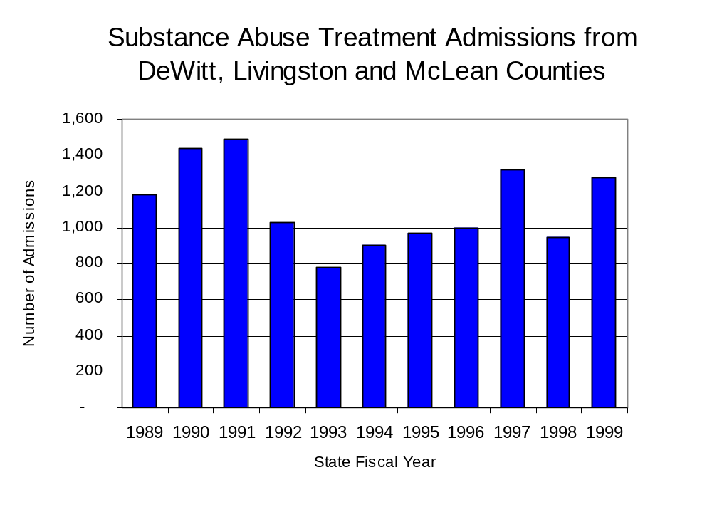
Figure 24
Source: Illinois Department of Human Services’
Office of Alcoholism and Substance Abuse
While drug treatment admissions can be considered a measure of the demand placed on a specific component of the human services system within Illinois, the extent and nature of drug treatment admissions could also be indicative of the substance abuse problem within a particular region. In some respects, the characteristics of those admitted to drug treatment can be considered a profile of the most serious drug abusers in the community, since admission to treatment requires a documented, formal assessment of a drug problem and a level of substance abuse warranting treatment. By comparing the types of drugs of abuse reported by those admitted to substance abuse treatment with the types of drugs involved in law enforcement agency arrests, one can get a sense of the degree to which arrests reflect the drugs which are most problematic within a community.

In the following analyses, the percent of arrests accounted for by drugs classified under Illinois’ Controlled Substances Act (primarily cocaine, heroin, and methamphetamine) versus the Cannabis Control Act (marijuana) across the participating agencies combined, non-participating agencies combined and Task Force 6 are compared to the proportion of drug treatment admissions accounted for by these groups of substances. From these comparisons, a number of general conclusions can be made. First, the proportion of arrests made by participating agencies and non-participating agencies accounted for by marijuana was very close to the proportion of drug treatment admissions from the covered region accounted for by these substances. Thus, there is considerable convergence between the drugs involved in participating agencies and non-participating agencies' arrests and treatment admissions. On the other hand, the majority of arrests by Task Force 6 were for controlled substance offenses. Thus, while local arrests may reflect the most widely available and used drug in the region, they tend not to involve the substances considered to be most serious (i.e., felony versus misdemeanor) nor the substances individuals are seeking and receiving treatment for (Figure 25).

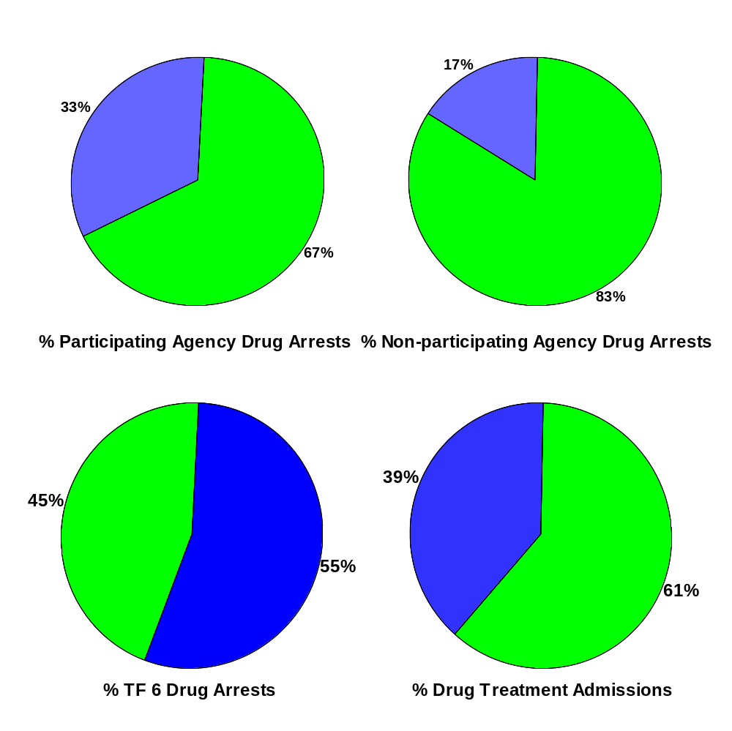
CannabisControlled Substances
Comparison of Drug Arrests by Task Force 6 and Participating and Non-participating Agencies vs. Drug Abuse Treatment Admissions in DeWitt, Livingston and McLean Counties, 1999
Source: Illinois Department of Human Service's Office of Alcoholism and Substance Abuse and Task Force 6
Figure 25

VIII. Trends in Drug Exposed Births

Illinois continues to experience the effects of prenatal substance abuse. In Illinois, if a baby is born and thought to have been exposed to illegal substances or alcohol, either through observation by physicians or toxicology tests, the case is reported to the Illinois Department of Children and Family Services. These cases are then investigated by DCFS to verify the child’s prenatal exposure to either alcohol or illegal substances. Between state fiscal years 1989 and 1999, nearly one-half (50) of Illinois’ 102 counties reported at least one case of a substance-affected infant.

Between state fiscal years 1989 and 1995, the number of drug-exposed infant cases reported in the three-county region covered by Task Force 6 nearly tripled, from four to a period high of 11, before decreasing nearly every year thereafter to five cases in 1999. Between state fiscal years 1989 and 1999, 46 cases, or nearly two-thirds of all cases reported, were verified as involving prenatal drug use by a DCFS investigation. Mirroring the trend of reported cases, verified cases of drug-exposed infants in the Task Force 6 region reached a period high of nine cases in 1995 before dropping to two in 1999 (Figure 26).

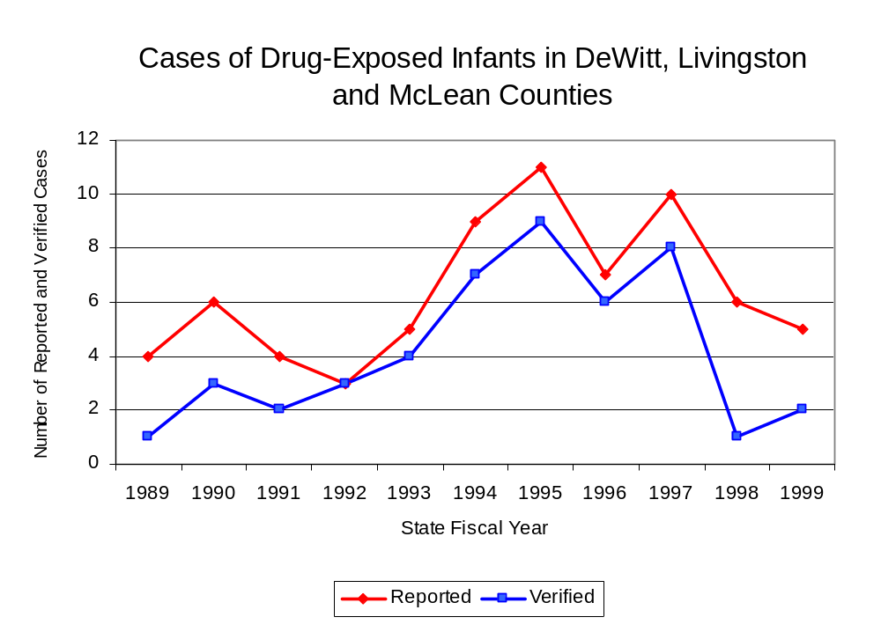
Source: Department of Children and Family Services
Figure 26

IX. Summary of Drug Situation

Although the distribution of illegal drugs is difficult to measure precisely, data obtained from criminal justice sources can be helpful in estimating drug availability. Information from a recent survey of Illinois drug enforcement units, as well as the most up-to-date data available on drug price, are presented as indicators of the drug supply in Illinois.

In 1995, 1996 and 1998, the Authority conducted a survey of each MEG and task force in Illinois to gauge the perceived availability of drugs in the areas they cover. Questions were asked concerning the availability of specific drugs, and results were analyzed by region of the state. MEGs and task forces are classified as being either urban, rural or mixed urban/rural based upon the classification of the county(s) that each unit covers, and, for purposes of this report, are compared to the average of similar units.

According to Task Force 6 survey responses, cannabis, cocaine and crack continued to be the most visible drugs on the street and were all reported to be “readily available” across all regions analyzed. While perceived availability of LSD decreased since the 1996 survey across all regions examined, the perceived availability of heroin and PCP increased across those same regions. The perceived availability of all drug types (excluding LSD) increased in other MEGs and task forces in urban/rural mixed regions. The perceived availability of cannabis, cocaine and crack remained relatively unchanged in the three-county region covered by Task Force 6. According to 1998 survey responses, cannabis was “easily available” across Illinois, other MEGs and task forces in urban/rural mixed regions and the area covered by Task Force 6. Methamphetamine was reported as moderately available across Illinois and other MEGs and task forces in urban/rural mixed regions but available to a lesser degree in the region covered by Task Force 6. The perceived availability of PCP tended to be greater across the region covered by Task Force 6 than other regions (Figure 27).
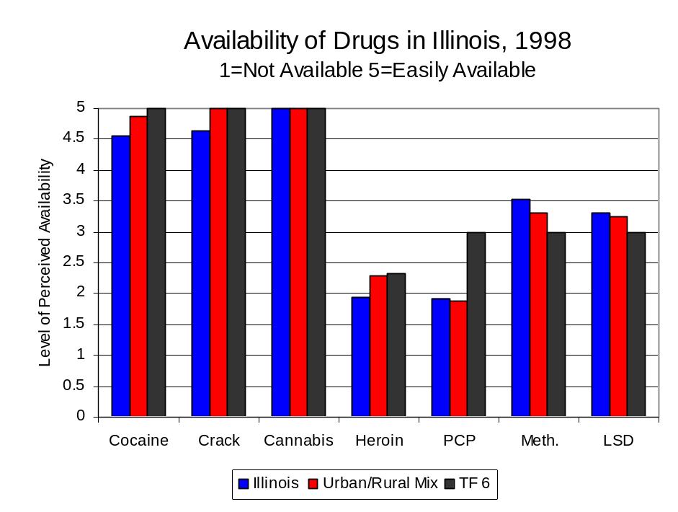
Figure 27
Source: Authority Survey of Illinois MEGs and task forces
Another market indicator that can be used to assess availability is drug price. Lower prices tend to suggest a sufficient supply to meet demand, while increasing prices indicate decreased availability.

Based on a statewide survey of MEG and task force units, the average price of cannabis, cocaine, crack and methamphetamine appear to be relatively stable across all regions surveyed in 1998, while prices for PCP and heroin appear to vary somewhat across Illinois. The average price of crack decreased across all regions between 1996 and 1998. The average price of cannabis, cocaine and methamphetamine increased across Illinois, while heroin increased in the region covered by Task Force 6 and other MEGs and task forces in urban/rural mixed regions. The 1998 average price of cocaine reported by Task Force 6 was $100 per gram, compared to $98 per gram across Illinois and $103 per gram reported by all MEGs and task forces in other urban/rural mixed regions (Figure 28). The average price of heroin in the region covered by Task Force 6 was reported as $400 per gram, significantly higher than the price of $165 per gram across Illinois and the price of $214 per gram reported by all other MEGs and task forces in urban/rural mixed regions. In 1998, the average price of cannabis was reported as approximately $7 per gram in urban/rural mixed regions and $8 per gram across Illinois.
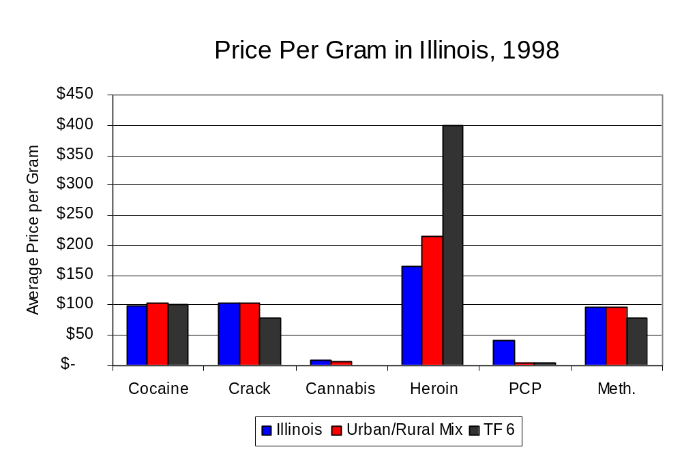
Figure 28
Source: Authority Survey of Illinois MEGs and task forces

X. Appendices
1999 Percent of Illinois'
County-level Population Covered by an Authority-funded Multi-jurisdictional Enforcement Group or task force
Map 1
* Shaded counties indicate that at least one law enforcement agency within the county participates in a MEG or task force
Percent of County Population Covered by MEG or task force

1999 Illinois
Cannabis
Seizure Rates, by County
Map 2
Cannabis Seizure Rate
(rate per 100,000 population)
1999 Illinois
Cocaine
Seizure Rates, by County
Map 3
Cocaine Seizure Rate
(rate per 100,000 population)
1999 Illinois Methamphetamine
Seizure Rates, by County
Map 4
Methamphetamine Seizure Rate
(rate per 100,000 population)

Bibliography

Administrative Office of the Illinois Courts, Annual Report to the Supreme Court of Illinois.
1989 through 1999 reports, Springfield, Illinois.

Administrative Office of the Illinois Courts’ Probation Division, Statewide Probation Data
Report. 1989 through 1999 reports, Springfield, Illinois.

Illinois Department of Human Services’ Office of Alcoholism and Substance Abuse. Data
provided for state fiscal years 1989 through 1999, Springfield, Illinois.

Illinois Department of Children and Family Services, Child Abuse/Neglect Statistics Report,
1989 through 1999 reports, Springfield, Illinois.

Illinois Department of Corrections. Data provided for fiscal years 1989 through 1999,
Springfield, Illinois.

Illinois State Police, Crime in Illinois. 1993 through 1999 reports, Springfield, Illinois.

Illinois State Police, Drug Statistics Report. Monthly reports, January 1989 through
December 1999, Springfield, Illinois.

North Central Narcotics task force. Monthly reports, January 1989 through December
1999, Bloomington, Illinois.

U.S. Bureau of the Census.


George H. Ryan, Governor
Peter B. Bensinger, Chairman
Candice M. Livingston, Executive Director

